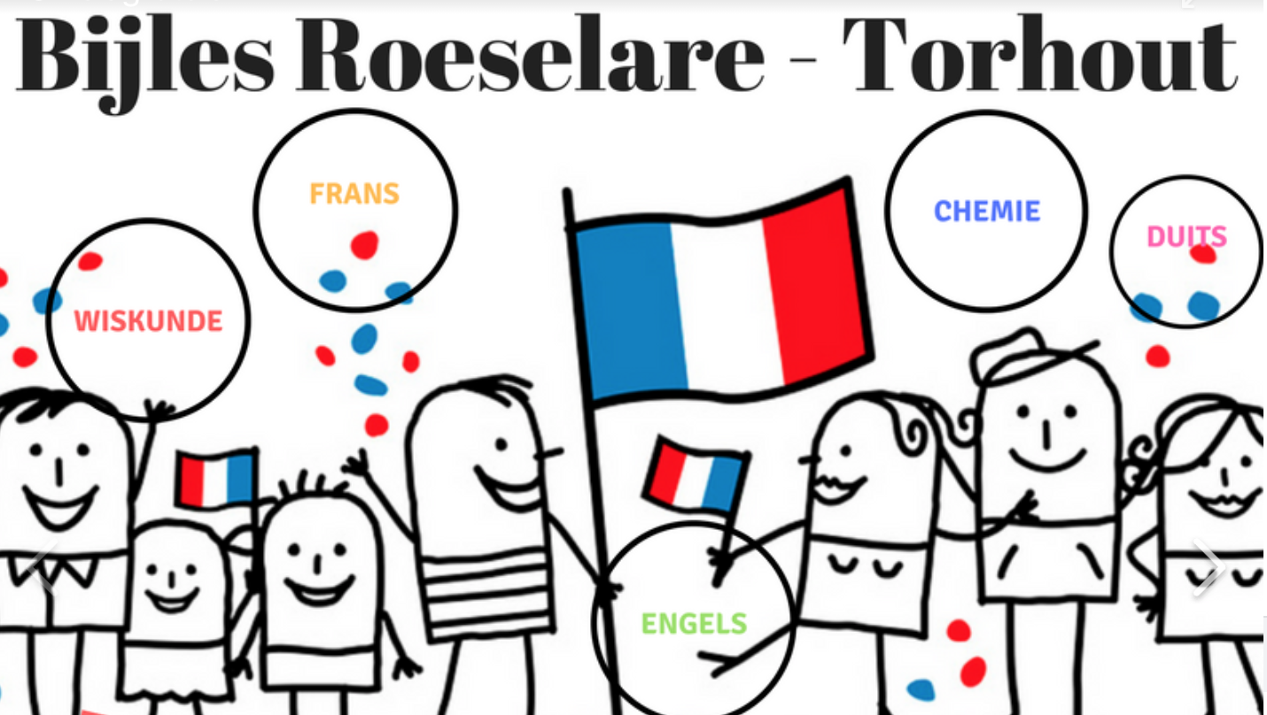
Tip en Top

Doel: _______________________________________________________________________
Top | Tip
Acties

